2009: The nation is changing – so why not you?
My thoughts for the New Year

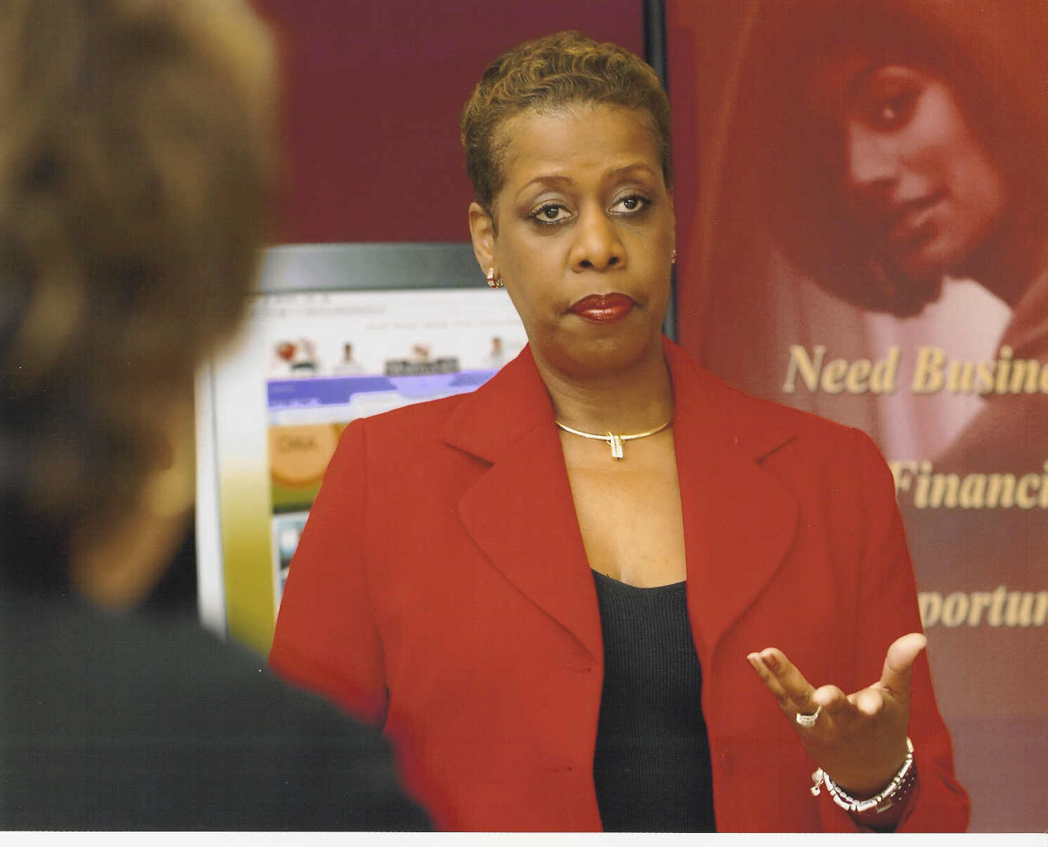 By Sharon Roberson Pinder

When we ring out the old year and ring in the new most people make resolutions for themselves and seldom for their businesses. For 2009 as we welcome our new President, I recommend three resolutions that can benefit you both personally and professionally.
- Get Rid of the Weight
Personally, most of us need a strategy to drop a few pounds. I am jumping back on the wagon with Oprah this month and hoping for the best. Weight seems to be our enemy and target at the beginning of each year. Although most of us may not qualify to compete on “The Biggest Losers”, the reality television show, our knees, our families and our insurance companies would greatly appreciate a reduction in our current weight.
In business, getting rid of the weight means things:
- Eliminate the debt
If you focus on your receivables you can pay your payables on time and increase your cash flow. Provide your clients with a “pay me early” incentive. Instead of the traditional net 30, tell them net 10 will get them a discount off of their invoice.

- Reduction in Staff
For some business owners, this is the first time you’ve ever had to reduce staff size because of the economy. View this time as an opportunity to proactively evaluate your personnel. Are they are performing to your level of expectations? More importantly, is their function still essential to your business. Play out all scenarios: what if you reduced salaries across the board, or cut back on days, or hired a different team?
- De-Boarding
Are you on too many boards or involved in too many non-productive groups. My rule of thumb is that if after 2 years you haven’t realized any business or developed any meaningful business relationships then it is time make a move!

- Get Rid of the Excuses

On numerous occasions I’ve put off playing golf, and spending quality time with my family because I am always working. In 2009, I am going to buy that set of new irons in hopes that it improves my game and find a way to get out on the course.

In business, if you qualify as a small, woman or minority owned business, get that certification. I agree it is an unfair burden. I think instead of certification we just need a registry. But it is what it is. Yes, it forces you to have your financials in order, but you leave money on the table if you lose out on a possible business lead because you lack the right certifications in the commercial and public sectors. Additionally, there’s a new head of state and you want to be prepared for federal government projects that may flow your way.

- Get Rid of the Clutter
I am no Dr. Phil, but I am convinced I will feel better if I clean out and organize my closet. I also have to attack the growing mound of mail on the kitchen counter and apologize for the party invitations I missed. I really need to move the pile of magazines beside the bed because I’ll probably never get to them this year either.
In our businesses, clutter is a distraction as well. If you have confidence in your data back-up procedures you can get rid of some of the paper. We know we are killing the trees, but we print if off anyway. Clear off the desk, file those papers and hide those wires from your phone, computer and other electronics around your workspace. You’ll feel better and you will be able to think better. When you can think clearly, your employees and clients are the beneficiary of your ideas and solutions.
The nation is changing and so can you.
Sharon R. Pinder is CEO of the Pinder Group and the Center for Business Inclusion and Diversity. She is the founder of the Top 100 MBE Awards Ceremony . She can be reached at sharon@thepindergroup.com or on the web at www.thepindergroup.com .

